B R Y N G W Y N S U R G E R Y
4 – 6 B r y n g w y n R o a d
N e w p o r t
N P 20 4 J S

Dr H.S. Narula Dr (Mrs) S.K. Narula
MBBS., MS, DODip Ther (Wales). MBBS, DRCOG. DFFP., MRCOG
DOcc Med (Lond) Dip Ther (Wales)

Dr M. Jadoon Dr (Mrs) S. Manasani
MRCP, DFSHR, MRCGP .MBBS, MRCP, MRCGP, DFFP

Dr (Mrs) B. Reed Dr (Mrs) H. Khan
BMBS, MRCGP MBBS, MRCGP

The doctors practice together as a non - limited partnership

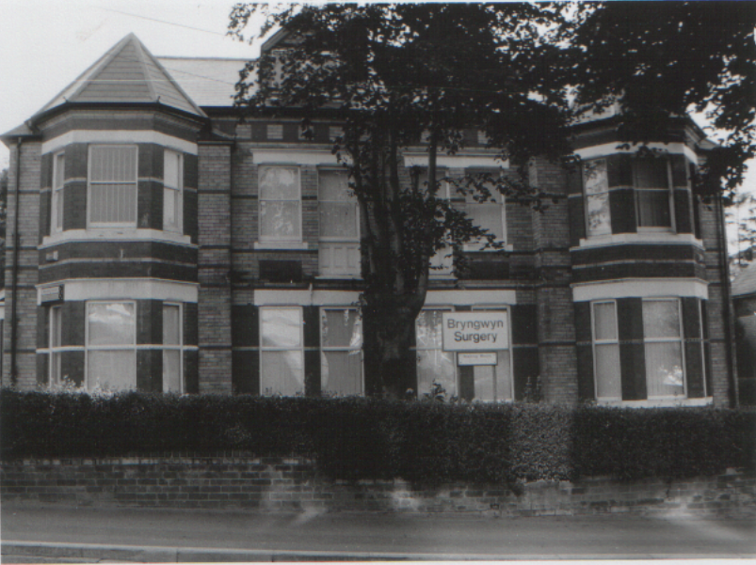
TEL: 01633 263463
FAX : 01633 252268
GENERAL ENQUIRIES EMAIL: enquiries.W93046@wales.nhs.uk
http://www.bryngwynsurgery.wales.nhs.uk
This practice leaflet and policy is regularly updated. If there is a policy change, the Health Board is informed. The information leaflet is correct to the best of our knowledge at the time of going to print. Updated May 2019

Practice Location
The practice is situated centrally in Newport, close to the Civic Centre, Railway station, Bus Station, Town, Royal Gwent and St. Woolos Hospitals. It covers mainly a 3 mile radius of practice population; please refer to the map on the back page.

Car Park
There is very limited car parking at the rear of the practice and for disabled drivers at the front. The rear car park is not suitable for large vehicles. Cars left on the premises will be at the owners` risk and the surgery is not liable for any damage. IT IS TO BE USED ONLY WHEN CALLING FOR TREATMENT OR BUSINESS IN THE SURGERY.

Disabled Access Facilities
There are dedicated parking spaces for disabled drivers and provision has been made for easy wheelchair access to the surgery. The surgery has fully adapted toilet facilities for the disabled. If you require assistance please ring the bell at the main entrance. We have a portable induction hearing loop for use at the reception and in consultations if required.

How to Register
Patients living within our catchment area may register with the practice. Please contact the reception staff who will advise you of the process and provide you with the necessary forms.

Surgery Opening Times - Office Hours - Monday–Friday 8.00am – 6.30pm

Appointments (GP & Nurse appointments available)
All consultations are by appointment which can be made by contacting the surgery. Patients who require urgent appointments can be seen in the Open Access Clinic every weekday morning. If the problem is urgent please ring between 8.00 & 9.00 am for an appointment. Routine appointments are available to pre-book up to 3 weeks in advance but please remember to cancel your appointment if you no longer require it.

Monday 8.30 am – 11.30 am 3.30 pm - 6.00 pm
Tuesday 8.30 am – 11.30 am 3.30 pm - 6.00 pm
Wednesday 8.30 am – 11.30 am 3.30 pm - 6.00 pm
Thursday 8.30 am – 11.30 am 4.30 pm - 6.00 pm
Friday 8.30 am – 11.30 am 3.30 pm - 6.00 pm

Extended Hours (GP & Nurse appointments available)
Wednesday 6.30 pm – 7.30 pm

The phone line can be very busy so if you can leave non-urgent calls until later in the morning we will be able to deal with them more quickly. MONDAYS ARE OUR BUSIEST DAYS. If your requirement is routine and non-urgent please telephone on another day.

You can request to be seen by a Doctor of your choice using our pre-bookable service and these routine appointments can be pre-booked up to 3 weeks in advance.

DNA (Did Not Attend) Policy
Patients who do not keep their appointment or fail to cancel and inform the practice on 2 occasions will be considered as non co-operative and will be asked to leave the list.

My Health On Line
You can book routine appointments with the Doctor via the internet – please ask the receptionist for information on how to register. You can also use MHOL to request repeat prescriptions www.myhealthonline-inps2.wales.nhs.uk

Consultations
These will be provided usually at 10 minute intervals. 10 minute Consultations usually can deal with on problem. It is not possible to deal with a list of problems in 10 minutes. In order for us to meet the patient charter you should advise the reception staff if you feel you need a longer appointment. We offer a Chaperone service in the practice; this can be requested at the time of your consultation. We will endeavour to see all patients will be seen within 30 minutes of their appointment.

Telephone Consultations
The practice encourages patients to phone for advice when a face to face appointment is not necessary. If you wish to speak to a doctor please telephone reception before 11.00 am and book a telephone consultation.

Home Visits
These are for patients who are too ill to attend the surgery. If possible please request a visit before 10.00 am, as this will help the doctor to plan the time of call.

Special Clinics
Antenatal Clinic (Monday pm) - Held by Midwife for the well-being of mother & baby.
Well Baby Clinic Appt Only with Health Visitor (Wednesday pm)
Well Baby Clinic Drop In (Wednesday 0930 to 1230)
Held with the Health Visitor & GP. Children under 5 are welcome for development screening immunization and general advice.
Minor Surgery Clinic (Tuesday mornings by appt only)
Minor surgery procedures are performed in a fully equipped treatment room
Patients aged over 75
Everyone over 75 is invited to have a simple examination once a year. It can be done either in the surgery or at the patient’s home.
Diabetic, Chronic Heart Disease and Asthma Checks
Regular check ups are done by the both the practice nurse and the GP’s
Immunisation / Travel Advice
Always book an appointment with the practice nurses as soon as you have made travel plans. The routine appointment waiting period with the nurses is around 2 weeks so please get your vaccinations well in advance and at least 4 weeks before travel.
Other Services
Near Patient testing (drug monitoring by blood testing)
Contraceptive services – fitting of IUD’s and implants

Calls Outside Surgery Hours
A doctor is always available 24 hours a day - Telephone following –
Monday to Friday 8.00 am – 6.30 pm 01633 263463
Monday to Friday 6.30 pm – 8.00 am 0845 6001231
Out of Hours & Weekends 0845 6001231
Alternately if your problem is not an emergency but you require medical advice, you may ring NHS Direct, the 24 hour nurse-led advice line on 0845 4647 (local rate) or consult NHS Direct online at www.nhsdirect.nhs.uk

Repeat Prescriptions
You can order your repeat prescriptions using MHOL please ask the receptionist how to get set up for this if you are not already. Alternatively please use the right hand paper of the prescription (counterfoil) to make the request and post in the dedicated post box in main reception. If a self addressed, stamped envelope is attached, the prescription will be posted to you, otherwise you can collect after 48 hours at the reception desk or the Pharmacy of your choice. No prescriptions are accepted over the telephone. We can accept a faxed prescription counterfoil as a request, but please avoid faxing handwritten requests as they may not be acceptable.
Repeat Dispensing - We can provide a repeat dispensing prescription authorising a number of repeat dispensing issue forms. If you are interested in this service please ask for more information.

Temporary Residents
Temporary residents can be seen during surgery hours or in an emergency. Patients from outside the European Union have to pay a fee now for non emergency services, please see fee section for details.

Test Results
Results are available daily between 12.00 pm and 2.00 pm. Contact the surgery for:
Urine tests after 2 working days
Blood tests after 2 Woking days
X-ray tests after 10 working days

General Telephone enquires
Please telephone between 11.30 am and 12.30 pm Monday to Friday when the receptionist will be able to help you with your query. Always leave your contact telephone number in case we have to ring you back or use our
enquiries email: enquiries.W93046@wales.nhs.uk

Nursing Team
Alison Underwood, RGN, BSC(Hons) Independent Prescriber
She is available to see patients with minor illness i.e sore throats, urine infections, chest infections etc.
Sister Karen Whatley, RGN and Sister Zuqia Ayub, RGN
Are available for health and dietary advice, travel immunisations and dressings, routine healthy heart, and telephone enquiry line. Sister Whatley has a special interest in Asthma and COPD and Sister Ayub a special interest in Diabetes.

Health Care Assistants
Mrs. Katrina Perry-Giles, NVQ (Health & Social Care), Mrs Glenys Cousins, NVQ (Health & Social Care)
She is available for taking blood samples, new patient and well person checks, B12 injections and flu vaccinations.

Practice Manager
Mrs. Sandra Bogue, BSc, PGDip (Leadership & Management)

Administrative and Reception Staff
All help for the smooth running of the surgeries, clinics, house calls and general running of the practice and medical secretarial support.

Other Members of Your Primary Health Care Team
District Nurses, Health Visitors, Community Midwives, Dietician, Counsellor, and Community Mental Health Worker. The Practice has direct access to physiotherapy, occupational therapy, chiropody, speech therapy, dietician, radiology, pathology departments and social services.

Students
Work experience students accepted by the educational authority may be present at the practice from time to time.

Confidentiality
All patient information will be treated in strict confidence. Access to all records will be limited to the people caring for the patient, including medical secretaries. Written notes to non-medical people will need written permission from the patient.

Complaints
We welcome any comments or suggestions you may have in writing or by using
the comments or suggestions book which is held in reception. If you feel un-
happy about any aspect of our service, please speak or write to the Practice
Manger, or request a copy of our complaints leaflet held at reception which
outlines the procedure.

Practice Charter
What we can do for you
We believe in good communication with our patients and others involved in providing health care. We believe you should be treated with respect, with dignity and in confidence. We believe you should know the name of all members of the Primary Health Care Team to whom you are speaking and the service you are to receive. We believe in acting promptly on any query or complaint you may have. We believe you are an equal partner in the care you receive and so can make your own decision about looking after yourself with guidance from our team.

What you can do for us
Please treat you surgery staff with due courtesy and respect. If you are unclear about your treatment please ask. Try to follow any medical advice you are given; you are partners in the care that you receive and we ask you to accept your own responsibilities in return. Please let us know as soon as you can if you cannot keep an appointment. Please respond promptly to any letters we may send you. Be understanding when your own consultation is delayed by someone else’s unexpected emergency. Many illnesses can be prevented through healthy living. Ask about the health promotion information on offer in the surgery. Screening programmes are invaluable in early detection of certain illness, please take advantage of them. It is your responsibility to keep the practice updated on your change of address and telephone numbers.

Why does the NHS collect Information about you?
Your Doctor and the team of health professionals caring for you keep records about your health and any treatment or care you receive from the NHS. This information will either be written down (manual records), or held on computer (electronic records). These records are then used to guide and manage the care you receive.

You may also be receiving care from organisations outside the NHS (like social services). If so we may need to share some information about you so that everyone involved in your care can work together for your benefit. Whenever this is necessary, your information will be handled in the strictest of confidence and will be subject to the principles of confidentiality. (WAG Autumn, 2002)

Access to Health Records
In general you have right to see your health records though certain legal exclusions may apply. You can ask to see your record and may request a copy of any part. In most cases we find it best for you to make an appointment so we can go through the record with you. If you require access to your record please ask to speak to the practice manager in the first instance.

Fees
Certain services provided by your doctor are not covered by the NHS. You may be asked to pay a fee e.g. private sick notes, BUPA forms, pre-employment medicals, insurance claims, medical reports, travel cancellation letters/reports etc. Non emergency consultations for patients outside the European Union will be required to pay a fee which will vary depending upon the type of work required. The minimum fee for a 10 minute consultation is £30.00

Research
The Practice has been approved by the Primary Care Research Incentive Scheme to participate in approved Research in Primary Care.

Health Data Collection and Health Observatory
The staff at this practice record information about you and your health so that you can receive the right care and treatment. We need to record this information, together with the details of the care you receive, so that it is available each time we see you. The information recorded about you may also be used for reasons other than your personal care, for example, to help to protect the health of the general public, to plan for the future, to train staff and to carry out medical and other health research or studies. Thus, we are involved in a health observatory based on anonymised patient information. The reasonable security measures and anonymisation processes are in place to comply with the relevant data protection regulations. If you would like to opt out of this data collection scheme, please let your doctor know and your records will not be collected for use for this Observatory. This will not affect your care in any way. If anything to do with the Observatory or derivate research would require that you provide additional information about yourself, you will be contacted by your GP to see if you are willing to take part; you will not be identified in any published results. You have a right of access to your health records. If at any time you would like to know more, or have any concerns about how we use your information, please ask reception for more details. A list of published research using the THIN database is available upon request. Please contact Michelle Page on telephone number 020 7501 7540 or email info@the-health-improvement-network.co.uk for a copy. Health Data Collection and Health Observatory
EVERYONE WORKING WITH OR FOR THE NHS HAS A LEGAL DUTY TO KEEP INFORMATION ABOUT YOU CONFIDENTIAL

VIOLENT OR ABUSIVE BEHAVIOUR
Practice procedures following any incidence of violent or aggressive behaviour will be:-

- To review the incident with the practice partners in order to determine its` severity
- To determine if the patient should be removed from the practice list forthwith.
- To take no further action as the matter has been sufficiently dealt with by the advice already given

Useful Contacts

Aneurin Bevan University Health Board
Llanarth House
Unit 1 Newbridge Gateway
Bridge Street
Newbridge. NP11 5GH

Tel: 01495 241200 Fax: 01495 241203

Out Of Hours 01633 744285
N.H.S. Direct 08454647
NH.S. Online http//www.nhsdirect.nhs.uk
Community Health Council 01633 838516 (24 hr answer)
01633 484623 (Fax)
Gwent Alcohol Project 01633 252045
Drug & Alcohol Related problems 01633 216777
Sesame Counselling 01633 263388
Royal Gwent Hospital 01633 234234
Action Aid for Disabled 01633 258212
Age Concern 01633 238295
Cruse (Bereavement Care) 0290 889227

